General
Diabetes prevention week
Cervical cancer month
Safe surgeries
Pentalin/gabapentin

Wembley and Burnley

- Burnley 46 % triple target 2
- Wembley 96% type 2 8cp’s
- Wembley 60% Type 2 triple target

Southwark
- 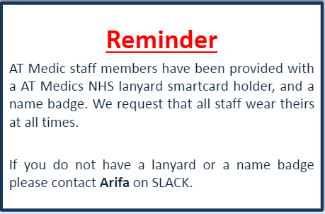

- 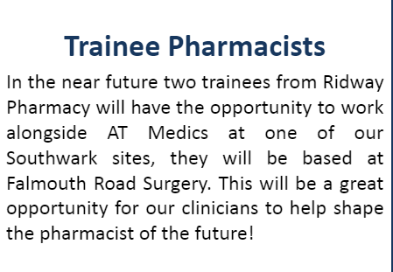

- Carers Event – queens road

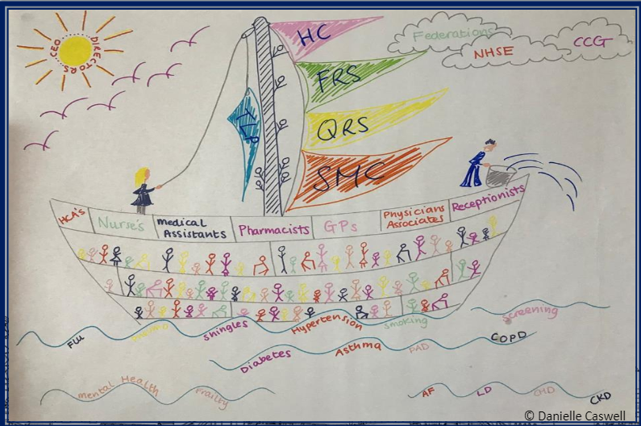

Mollison Way Surgery

Somers Town
Annual health checks for people with learning disabilities. There is still £56,500 of income to be claimed in 2018/19 by Camden Practices for performing annual health checks for people on their QOF learning disability register. People with learning disabilities suffer a range of health inequalities and research has highlighted that an annual health check can make a difference in addressing these issues, and can build familiarity and confidence in accessing health services.
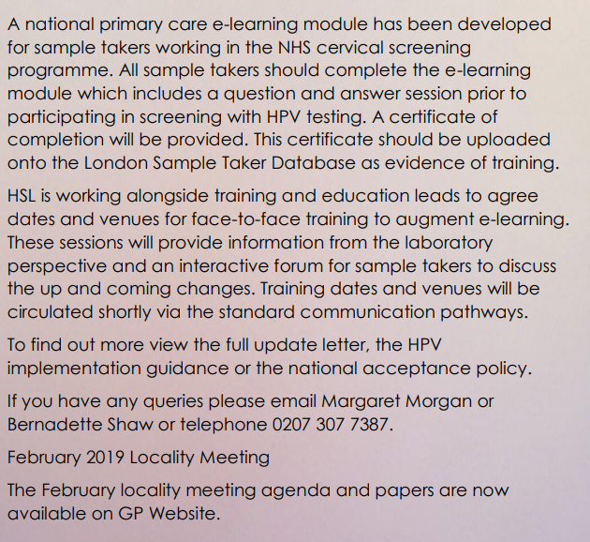

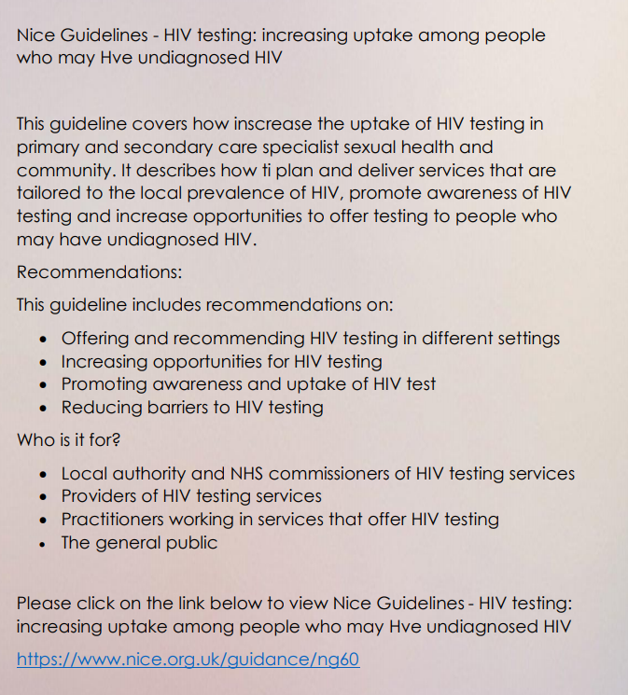

Canberra
